E-COMMERCE SHOE WEBSITE USING FRONT END DEVELOPMENT

PARTICIPATED STUDENTS : B. Sai kiran (20HQ1A0502)

B.Sai tharun(20HQ1A0503)

CH.Mouni (20HQ1A0505)

M.Gowri Venkata raju ( 20HQ1A0521)

N.Vybhavi (20HQ1A0522)

1.INTRODUCTION

1.1 : Overview

**What is ecommerce web development?**

Ecommerce web development is the process of building and designing an ecommerce website where consumers can purchase products online. Because ecommerce websites are so popular with consumers, developing an ecommerce website can help you [generate more conversions](https://www.webfx.com/web-design/services/conversion-design/) and revenue for your business.

1.2: Purpose

## The Purpose of Informational Website

**Definition:** the informational website is a large web portal, organized as a multi-level integration of various resources and services, which are updated in real-time.

The informational website contains an enormous amount of unique content. Sites of this type have a complex structure and navigation and contain various interactive services. Informational websites are designed for a large number of visitors.

**The purpose:** the main purpose of the informational website is **to help users to find the necessary information on a specific topic.** Due to the special website functions, all the data available on the website is easy to structure and systematize, which makes working with it as efficient and convenient as possible. In this case, the informational website acts as a user’s guide on the Web, which, compared to search engines, greatly simplifies the search for thematic materials.

2.THEORITICAL ANALYSIS

2.1 block diagram

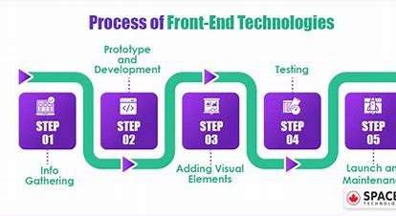

**RESULT**

|  |
| --- |
|  |
| <!DOCTYPE html> |
|  |  | <!-- saved from url=(0122)file:///C:/Users/sai%20kiran%20boddepalli/AppData/Local/Temp/Temp1_Ecommerce%20(2).zip/Ecommerce/Ecommerce/index.html#cart --> |
|  |  | <html lang="en"><head><meta http-equiv="Content-Type" content="text/html; charset=UTF-8"> |
|  |  |  |
|  |  | <meta name="viewport" content="width=device-width, initial-scale=1.0"> |
|  |  | <title>Shoe Store</title> |
|  |  | <link rel="stylesheet" href="file:///C:/Users/sai%20kiran%20boddepalli/AppData/Local/Temp/Temp1_Ecommerce%20(2).zip/Ecommerce/Ecommerce/styles.css"> |
|  |  | <link rel="stylesheet" href="./Shoe Store_files/bootstrap.min.css"> |
|  |  | </head> |
|  |  | <body> |
|  |  | <nav class="navbar navbar-expand-lg navbar-light bg-white"> |
|  |  | <a class="navbar-brand" href="file:///C:/Users/sai%20kiran%20boddepalli/AppData/Local/Temp/Temp1_Ecommerce%20(2).zip/Ecommerce/Ecommerce/index.html#"> |
|  |  | <img class="imagesize" src="./Shoe Store_files/shoes-store-logo-icon-vector-260nw-1718722330_1_2_qlurv9.png"> |
|  |  | </a> |
|  |  | <button class="navbar-toggler" type="button" data-toggle="collapse" data-target="#navbarNav" aria-controls="navbarNav" aria-expanded="false" aria-label="Toggle navigation"> |
|  |  | <span class="navbar-toggler-icon"></span> |
|  |  | </button> |
|  |  | <div class="collapse navbar-collapse" id="navbarNav"> |
|  |  | <ul class="navbar-nav"> |
|  |  | <li class="nav-item active"> |
|  |  | <a class="nav-link size" href="file:///C:/Users/sai%20kiran%20boddepalli/AppData/Local/Temp/Temp1_Ecommerce%20(2).zip/Ecommerce/Ecommerce/index.html">Home</a> |
|  |  | </li> |
|  |  | <li class="nav-item"> |
|  |  | <a class="nav-link size" href="file:///C:/Users/sai%20kiran%20boddepalli/AppData/Local/Temp/Temp1_Ecommerce%20(2).zip/Ecommerce/Ecommerce/index.html#productSection">Products</a> |
|  |  | </li> |
|  |  |  |
|  |  | <li class="nav-item"> |
|  |  | <a class="nav-link size" href="file:///C:/Users/sai%20kiran%20boddepalli/AppData/Local/Temp/Temp1_Ecommerce%20(2).zip/Ecommerce/Ecommerce/index.html#cat">Categories</a> |
|  |  | </li> |
|  |  | <li class="nav-item"> |
|  |  | <a class="nav-link size" href="file:///C:/Users/sai%20kiran%20boddepalli/AppData/Local/Temp/Temp1_Ecommerce%20(2).zip/Ecommerce/Ecommerce/index.html#new">New Arrivals</a> |
|  |  | </li> |
|  |  | <div> |
|  |  | <li class="nav-item"> |
|  |  | <a class="nav-link size" href="file:///C:/Users/sai%20kiran%20boddepalli/AppData/Local/Temp/Temp1_Ecommerce%20(2).zip/Ecommerce/Ecommerce/index.html#contact">Contact us</a> |
|  |  | </li> |
|  |  | </div> |
|  |  | </ul> |
|  |  | </div> |
|  |  | <div class="ml-auto"> |
|  |  | <p> |
|  |  | <a href="file:///C:/Users/sai%20kiran%20boddepalli/AppData/Local/Temp/Temp1_Ecommerce%20(2).zip/Ecommerce/Ecommerce/index.html#cart"> |
|  |  | <img class="imagesize1" src="./Shoe Store_files/shoes-shop-logo-vector-store-260nw-1718721763_1_txtzcp.png"> |
|  |  | </a> |
|  |  | </p> |
|  |  | </div> |
|  |  | </nav> |
|  |  |  |
|  |  | <div id="carouselExampleIndicators" class="carousel slide" data-ride="carousel"> |
|  |  | <ol class="carousel-indicators"> |
|  |  | <li data-target="#carouselExampleIndicators" data-slide-to="0" class=""></li> |
|  |  | <li data-target="#carouselExampleIndicators" data-slide-to="1" class="active"></li> |
|  |  | <li data-target="#carouselExampleIndicators" data-slide-to="2" class=""></li> |
|  |  | </ol> |
|  |  | <div class="carousel-inner"> |
|  |  | <div class="carousel-item"> |
|  |  | <img src="./Shoe Store_files/file.ob.jpg" class="d-block w-100" alt="Image 1"> |
|  |  | </div> |
|  |  | <div class="carousel-item active"> |
|  |  | <img src="./Shoe Store_files/file.ob(1).jpg" class="d-block w-100" alt="Image 2"> |
|  |  | </div> |
|  |  | <div class="carousel-item"> |
|  |  | <img src="./Shoe Store_files/file.ob(2).jpg" class="d-block w-100" alt="Image 3"> |
|  |  | </div> |
|  |  | </div> |
|  |  | <a class="carousel-control-prev" href="file:///C:/Users/sai%20kiran%20boddepalli/AppData/Local/Temp/Temp1_Ecommerce%20(2).zip/Ecommerce/Ecommerce/index.html#carouselExampleIndicators" role="button" data-slide="prev"> |
|  |  | <span class="carousel-control-prev-icon" aria-hidden="true"></span> |
|  |  | <span class="sr-only">Previous</span> |
|  |  | </a> |
|  |  | <a class="carousel-control-next" href="file:///C:/Users/sai%20kiran%20boddepalli/AppData/Local/Temp/Temp1_Ecommerce%20(2).zip/Ecommerce/Ecommerce/index.html#carouselExampleIndicators" role="button" data-slide="next"> |
|  |  | <span class="carousel-control-next-icon" aria-hidden="true"></span> |
|  |  | <span class="sr-only">Next</span> |
|  |  | </a> |
|  |  | </div> |
|  |  | <div> |
|  |  | <img class="m" src="./Shoe Store_files/file.jpg"> |
|  |  | </div> |
|  |  |  |
|  |  | <div> |
|  |  | <h1 id="productSection" class="heading">Featured Products</h1> |
|  |  | <div class="imgs d-flex flex-row justify-content-between"> |
|  |  | <img src="./Shoe Store_files/file.jpeg"> |
|  |  | <img src="./Shoe Store_files/file(1).jpg"> |
|  |  | </div> |
|  |  | </div> |
|  |  |  |

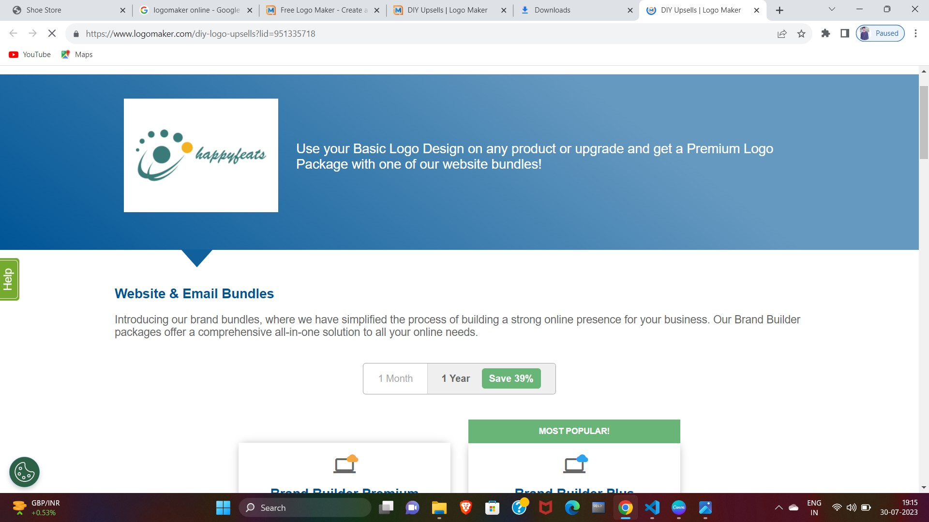

|  |
| --- |
| <div> |
|  |  | <h1 id="cat" class="heading">Top Categories</h1> |
|  |  | <div class="d-flex flex-row"> |
|  |  | <div class="m-5"> |
|  |  | <img src="./Shoe Store_files/file.pcp.jpg"> |
|  |  |  |
|  |  | <p class="sub-head text-center">RUNNING</p> |
|  |  | <div class="text-center"> |
|  |  | <button id="runningBtn" class="btn btn-primary">shop Now</button> |
|  |  | </div> |
|  |  | </div> |
|  |  | <div class="m-5"> |
|  |  | <img src="./Shoe Store_files/file.pcp(1).jpg"> |
|  |  |  |
|  |  | <p class="sub-head text-center">SPORTSTYLE</p> |
|  |  | <div class="text-center"> |
|  |  | <button id="sportBtn" class="btn btn-primary">shop Now</button> |
|  |  | </div> |
|  |  | </div> |
|  |  |  |
|  |  | <div class="m-5"> |
|  |  | <img src="./Shoe Store_files/file.pcp(2).jpg"> |
|  |  |  |
|  |  | <p class="sub-head text-center">APPAREL</p> |
|  |  | <div class="text-center"> |
|  |  | <button id="apparelBtn" class="btn btn-primary">shop Now</button> |
|  |  | </div> |
|  |  | </div> |
|  |  | <div class="m-5"> |
|  |  | <img src="./Shoe Store_files/file.pcp(3).jpg"> |
|  |  |  |
|  |  | <p class="sub-head text-center">PERFORMANCE</p> |
|  |  | <div class="text-center"> |
|  |  | <button id="performanceBtn" class="btn btn-primary">shop Now</button> |
|  |  | </div> |
|  |  | </div> |
|  |  | </div> |
|  |  | </div> |
|  |  | <div> |
|  |  | <h1 id="new" class="heading">NEW ARRIVALS</h1> |
|  |  | <div class="d-flex flex-row"> |
|  |  | <div> |
|  |  | <img src="./Shoe Store_files/file.thrb.jpeg"> |
|  |  | </div> |
|  |  | <div> |
|  |  | <img src="./Shoe Store_files/file.thrb(1).jpeg"> |
|  |  | </div> |
|  |  | <div> |
|  |  | <img src="./Shoe Store_files/file.thrb(2).jpeg"> |
|  |  | </div> |
|  |  | </div> |
|  |  | </div> |
|  |  | <h1 class="heading mt-4">RECOMMENDED PRODUCTS</h1> |
|  |  |  |
|  |  | <div class="d-flex flex-row justify-content-between"> |
|  |  | <div class="bg shadow"> |
|  |  | <img src="./Shoe Store_files/1201A789_001_SR_RT_GLB.jpg" alt="Product 1" class="image"> |
|  |  | <h4>GEL-KAYANO 29</h4> |
|  |  | <p class="main"> |
|  |  | The GEL-KAYANO® 29 shoe creates a stable running experience and a more |
|  |  | responsive feel underfoot. |
|  |  | </p> |
|  |  | <p class="main">$49.99</p> |
|  |  | <button class="btn btn-primary add-to-cart-btn" data-id="1"> |
|  |  | Add to Cart |
|  |  | </button> |
|  |  | </div> |
|  |  | <div class="bg shadow"> |
|  |  | <img src="./Shoe Store_files/1202A380_700_SR_RT_GLBNSW.jpg" alt="Product 2" class="image"> |
|  |  | <h4>METASPEED EDGE+</h4> |
|  |  | <p class="main"> |
|  |  | The METASPEED™ EDGE+ racing shoes are designed for cadence-style |
|  |  | runners who are looking to start fast and finish faster. |
|  |  | </p> |
|  |  | <p class="main">$59.99</p> |
|  |  | <button class="btn btn-primary add-to-cart-btn" data-id="2"> |
|  |  | Add to Cart |
|  |  | </button> |
|  |  | </div> |
|  |  | <div class="bg shadow"> |
|  |  | <img src="./Shoe Store_files/1202A254_960_SR_RT_GLB1.jpg" alt="Product 3" class="image"> |
|  |  | <h4>MAGIC SPEED 2</h4> |
|  |  | <p class="main"> |
|  |  | The MAGIC SPEED™ 2 shoe offers the energy you need to move towards a |
|  |  | new personal best. |
|  |  | </p> |
|  |  | <p class="main">$69.99</p> |
|  |  | <button class="btn btn-primary add-to-cart-btn" data-id="1"> |
|  |  | Add to Cart |
|  |  | </button> |
|  |  | </div> |
|  |  | <div class="bg shadow"> |
|  |  | <img src="./Shoe Store_files/1011B440_005_SR_RT_GLB.jpg" alt="Product41" class="image"> |
|  |  | <h4>GEL-QUANTUM 180 VII</h4> |
|  |  | <p class="main"> |
|  |  | "The GEL-QUANTUM 180™ VII sneaker combines a futuristic shape . |
|  |  | </p> |
|  |  | <p class="main">$79.99</p> |
|  |  | <button class="btn btn-primary add-to-cart-btn" data-id="1"> |
|  |  | Add to Cart |
|  |  | </button> |
|  |  | </div> |
|  |  | </div> |

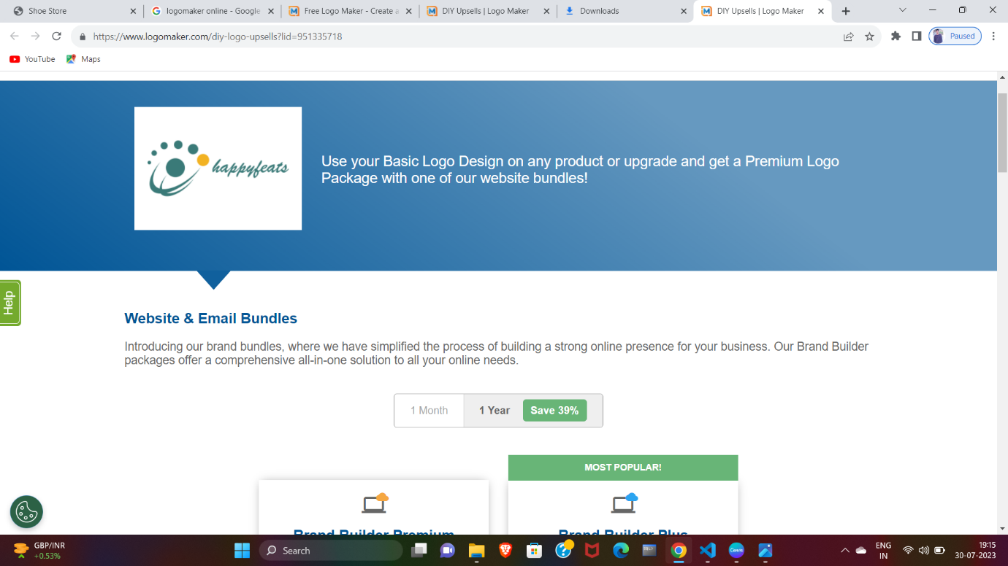

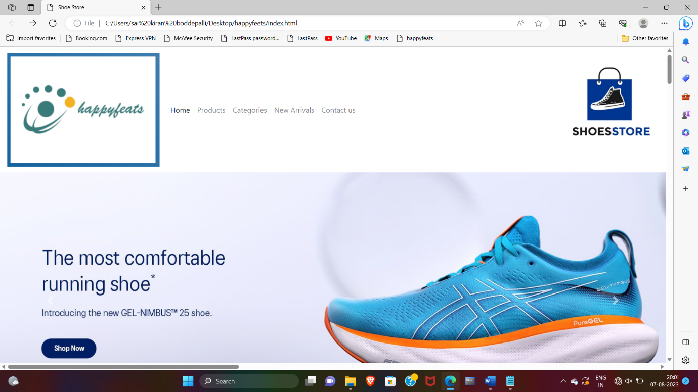

|  |
| --- |
| <div class="d-flex flex-row justify-content-between"> |
|  |  | <div class="bg shadow"> |
|  |  | <img src="./Shoe Store_files/1011B547_021_SR_RT_GLB.jpg" alt="Product 1" class="image"> |
|  |  | <h4>GEL-NIMBUS 25</h4> |
|  |  | <p class="main"> |
|  |  | "The GEL-NIMBUS® 25 shoe's soft cushioning properties help you feel |
|  |  | like you're landing on clouds. |
|  |  | </p> |
|  |  | <p class="main">$89.99</p> |
|  |  | <button class="btn btn-primary add-to-cart-btn" data-id="1"> |
|  |  | Add to Cart |
|  |  | </button> |
|  |  | </div> |
|  |  | <div class="bg shadow"> |
|  |  | <img src="./Shoe Store_files/1011B203_003_SR_RT_GLB.jpg" alt="Product 2" class="image"> |
|  |  | <h4>GEL-KINSEI BLAST</h4> |
|  |  | <p class="main"> |
|  |  | The Gel-Kinsei Blast Shoes Are Designed For Distance Runners Seeking A |
|  |  | Smooth Stride. . |

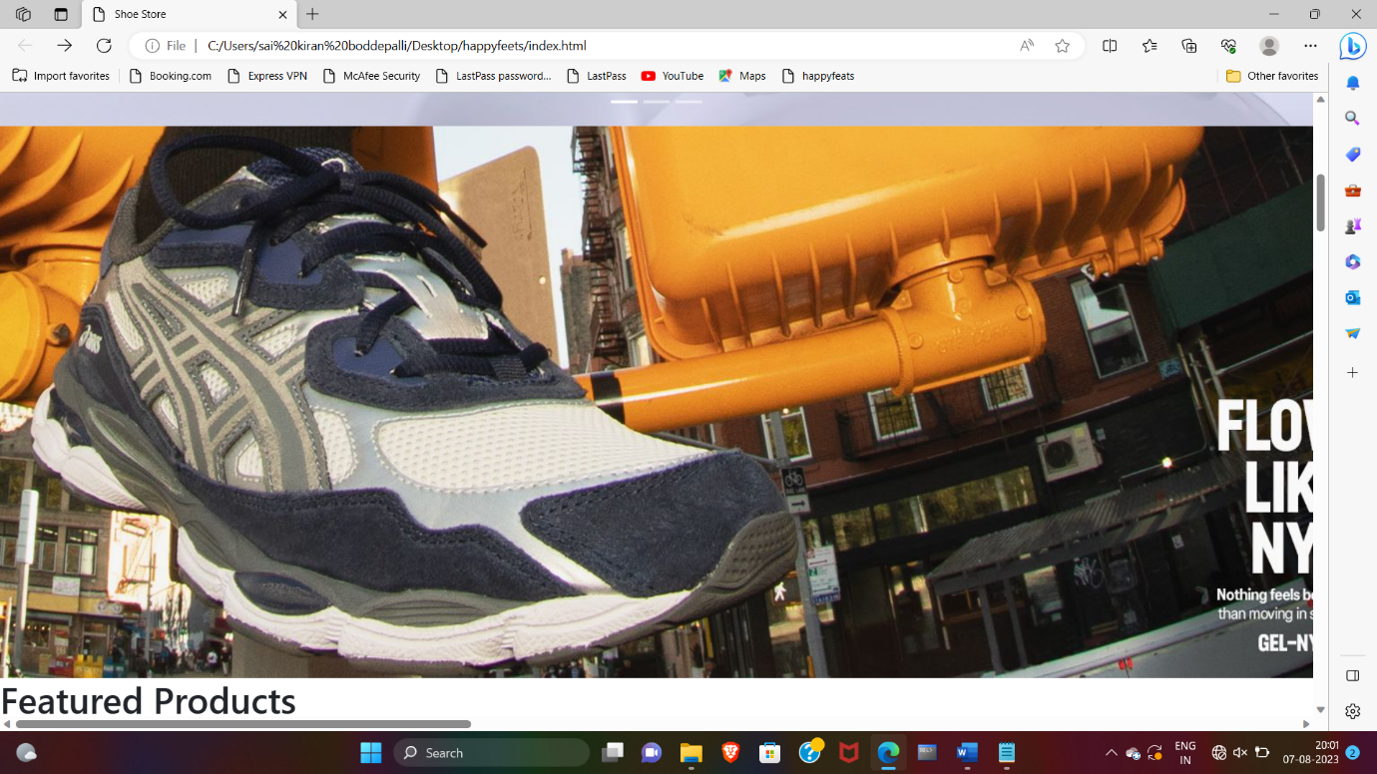

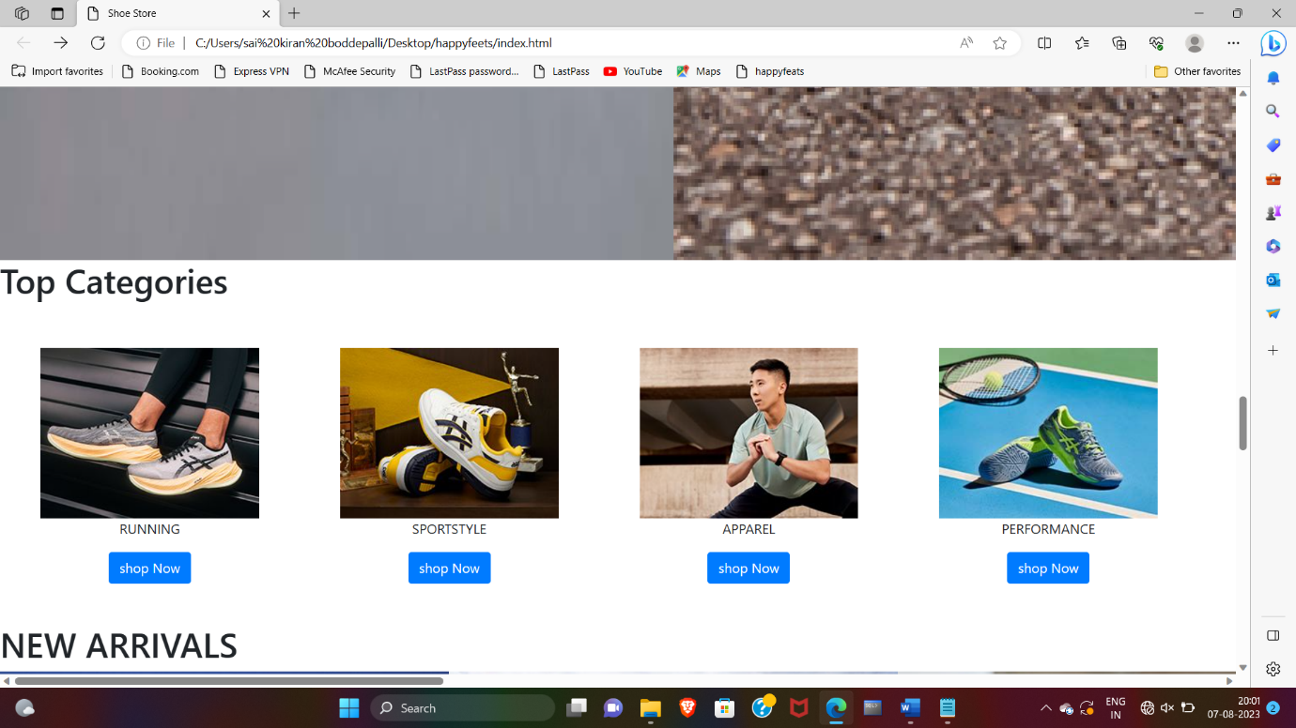

|  |
| --- |
| </p> |
|  |  | <p class="main">$99.99</p> |
|  |  | <button class="btn btn-primary add-to-cart-btn" data-id="2"> |
|  |  | Add to Cart |
|  |  | </button> |
|  |  | </div> |
|  |  | <div class="bg shadow"> |
|  |  | <img src="./Shoe Store_files/1011B592_400_SR_RT_GLB.jpg" alt="Product 3" class="image"> |
|  |  | <h4>GEL-KINSEI BLAST LE 2</h4> |
|  |  | <p class="main"> |
|  |  | The Gel-Kinsei Blast Shoes Are Designed For Distance Runners Seeking A |
|  |  | Smooth Stride. |
| </p> |
|  |  | <p class="main">$95.99</p> |
|  |  | <button class="btn btn-primary add-to-cart-btn" data-id="1"> |
|  |  | Add to Cart |
|  |  | </button> |
|  |  | </div> |
|  |  | <div class="bg shadow"> |
|  |  | <img src="./Shoe Store_files/1041A298_002_SR_RT_GLB.jpg" alt="Product41" class="image"> |
|  |  | <h4>SOLUTION SWIFT FF</h4> |
|  |  | <p class="main"> |
|  |  | The Fastest Model In The Asics Tennis Range, Our Solution Speed Ff 2 |
|  |  | Shoe Is All About Helping Players Expand Their Territory On The Court. |

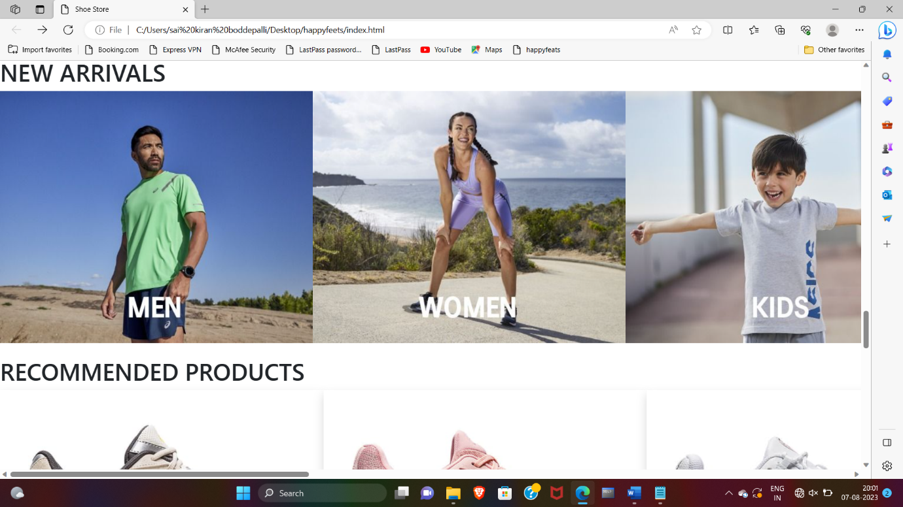

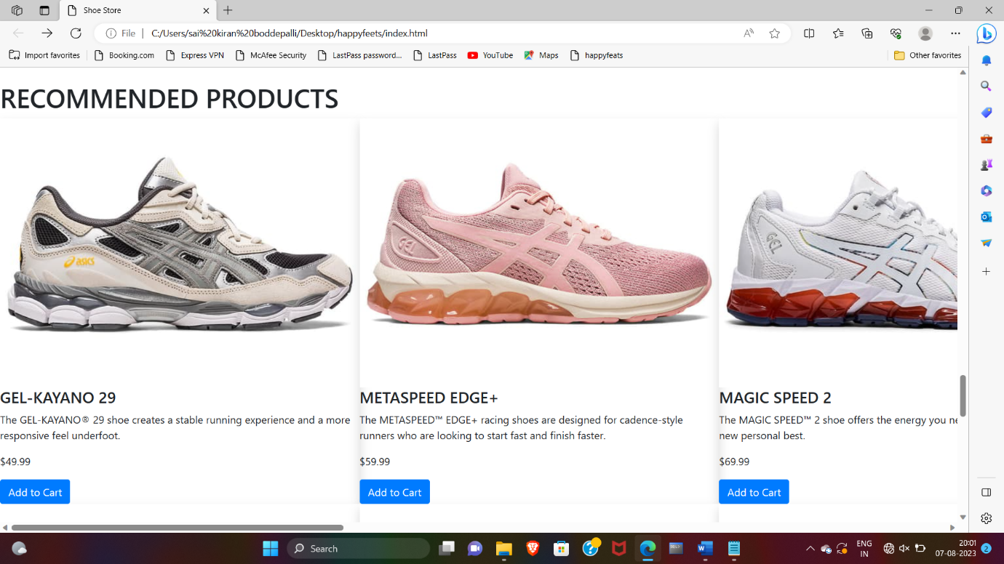

|  |
| --- |
| <p class="main">$97.99</p> |
|  |  | <button class="btn btn-primary add-to-cart-btn" data-id="1"> |
|  |  | Add to Cart |
|  |  | </button> |
|  |  | </div> |
|  |  | </div> |
|  |  |  |
|  |  | <div class="container mt-5"> |
|  |  | <h2 id="cart">Cart</h2> |
|  |  | <div id="cart-items"></div> |
|  |  | <p>Total items in cart: <span id="cart-count">0</span></p> |
|  |  | </div> |
|  |  |  |
|  |  | <h1 class="follow-us-section-heading">Follow Us</h1> |
|  |  |  |
|  |  | <div class="d-flex flex-row justify-content-center"> |
|  |  | <div class="follow-us-icon-container"> |
|  |  | <i class="clr fab fa-twitter icon" aria-hidden="true"></i> |
|  |  | </div> |
|  |  | <div class="follow-us-icon-container"> |
|  |  | <i class="clr fab fa-instagram icon" aria-hidden="true"></i> |
|  |  | </div> |
|  |  | <div class="follow-us-icon-container"> |
|  |  | <i class="clr fab fa-facebook icon" aria-hidden="true"></i> |
|  |  | </div> |
|  |  | </div> |
|  |  |  |
|  |  | <div id="contact" class="footer-section pt-5 pb-5"> |
|  |  | <div class="container"> |
|  |  | <div class="row"> |
|  |  | <div class="col-12 text-center"> |
|  |  | <img src="./Shoe Store_files/images" class="imagesize"> |
|  |  | <h1 class="footer-section-mail-id">happyfeets@footsteps.in</h1> |
|  |  | <p class="footer-section-address"> near maddilapalem ,visakhapatnam</p> |
|  |  | <p class="footer-section-address"> |
|  |  | Contact details: 1800 3000 9009 |
|  |  | </p> |
|  |  | </div> |
|  |  | </div> |
|  |  | </div> |
|  |  | </div> |

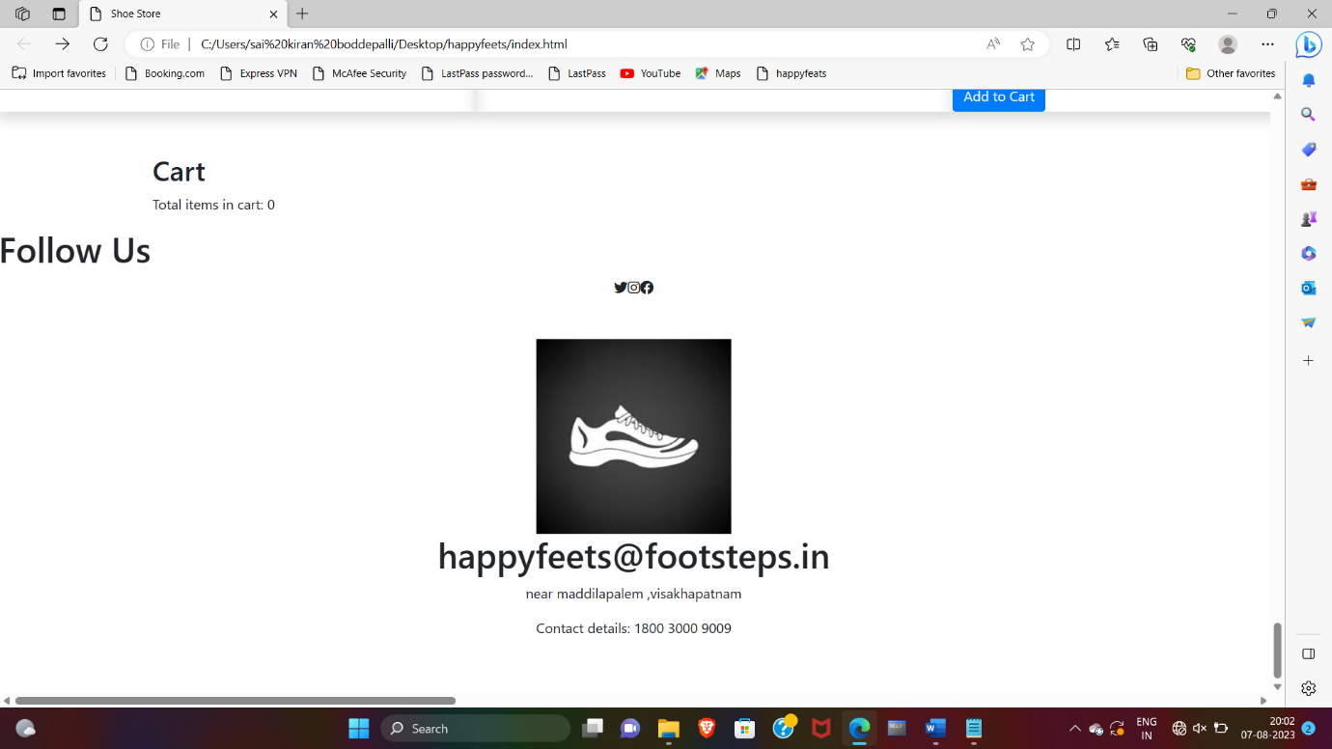

ADVANTAGES AND DISADVANTAGES OF E-COMMERCE

* [Advantages of E-commerce Business](https://adilblogger.com/advantages-disadvantages-e-commerce-business/#advantages-of-e-commerce-business)
  + [1. Faster Buying and Selling](https://adilblogger.com/advantages-disadvantages-e-commerce-business/#1-faster-buying-and-selling)
  + [2. Eliminate Operating Cost](https://adilblogger.com/advantages-disadvantages-e-commerce-business/#2-eliminate-operating-cost)
  + [3. Flexibility of the Business](https://adilblogger.com/advantages-disadvantages-e-commerce-business/#3-flexibility-of-the-business)
  + [4. Access to the Customer’s Data](https://adilblogger.com/advantages-disadvantages-e-commerce-business/#4-access-to-the-customers-data)
  + [5. Personalized Shopping Experience](https://adilblogger.com/advantages-disadvantages-e-commerce-business/#5-personalized-shopping-experience)
  + [6. Global Reach Audience](https://adilblogger.com/advantages-disadvantages-e-commerce-business/#6-global-reach-audience)
  + [7. Retargeting Customers](https://adilblogger.com/advantages-disadvantages-e-commerce-business/#7-retargeting-customers)
  + [8. Reduced Cost on Both Sides – Sale Representative and Customers](https://adilblogger.com/advantages-disadvantages-e-commerce-business/#8-reduced-cost-on-both-sides-sale-representative-and-customers)
  + [9. Save Times for Customers](https://adilblogger.com/advantages-disadvantages-e-commerce-business/#9-save-times-for-customers)
  + [10. Detailed Product Information](https://adilblogger.com/advantages-disadvantages-e-commerce-business/#10-detailed-product-information)
  + [11. Lower Costs of Maintaining Store](https://adilblogger.com/advantages-disadvantages-e-commerce-business/#11-lower-costs-of-maintaining-store)
  + [12. More Effective and Affordable Marketing](https://adilblogger.com/advantages-disadvantages-e-commerce-business/#12-more-effective-and-affordable-marketing)
  + [13. Business Automation](https://adilblogger.com/advantages-disadvantages-e-commerce-business/#13-business-automation)
  + [14. Ability to Handle Multiple Purchases](https://adilblogger.com/advantages-disadvantages-e-commerce-business/#14-ability-to-handle-multiple-purchases)
  + [15. Unlimited Scalability Opportunities](https://adilblogger.com/advantages-disadvantages-e-commerce-business/#15-unlimited-scalability-opportunities)
  + [16. More Sales Channel](https://adilblogger.com/advantages-disadvantages-e-commerce-business/#16-more-sales-channel)
  + [Disadvantages of Ecommerce Business](https://adilblogger.com/advantages-disadvantages-e-commerce-business/#disadvantages-of-ecommerce-business)
    - [1. Lack of Personal Touch](https://adilblogger.com/advantages-disadvantages-e-commerce-business/#1-lack-of-personal-touch)
    - [2. Fraud and Fake Orders](https://adilblogger.com/advantages-disadvantages-e-commerce-business/#2-fraud-and-fake-orders)
    - [3. Security Issues](https://adilblogger.com/advantages-disadvantages-e-commerce-business/#3-security-issues)
    - [4. Long Delivery Period](https://adilblogger.com/advantages-disadvantages-e-commerce-business/#4-long-delivery-period)
    - [5. Required Experts for Store Management](https://adilblogger.com/advantages-disadvantages-e-commerce-business/#5-required-experts-for-store-management)
    - [6. Customer’s Concern About Privacy](https://adilblogger.com/advantages-disadvantages-e-commerce-business/#6-customers-concern-about-privacy)
    - [7. Lack of Store Engagement with Customers](https://adilblogger.com/advantages-disadvantages-e-commerce-business/#7-lack-of-store-engagement-with-customers)
    - [8. Uncertainty about the product quality](https://adilblogger.com/advantages-disadvantages-e-commerce-business/#8-uncertainty-about-the-product-quality)
    - [9. Complex taxation Guidelines](https://adilblogger.com/advantages-disadvantages-e-commerce-business/#9-complex-taxation-guidelines)
    - [10. Limits on Some Purchases](https://adilblogger.com/advantages-disadvantages-e-commerce-business/#10-limits-on-some-purchases)
    - [11. The Risk of Downtime and Technology Issues](https://adilblogger.com/advantages-disadvantages-e-commerce-business/#11-the-risk-of-downtime-and-technology-issues)
    - [12. Online Global Competition](https://adilblogger.com/advantages-disadvantages-e-commerce-business/#12-online-global-competition)
    - [13. Negative Review and Rating](https://adilblogger.com/advantages-disadvantages-e-commerce-business/#13-negative-review-and-rating)

# 1. Retail

Electronic-retailing, often recognize as online retailing with the sale of products and services by businesses to customers through online stores. This is done by using tools such as virtual shopping carts and electronic-catalogs. There are manifold e-commerce applications in this field.

# 2. Accounting

Finance, electronic-commerce are more intertwined than ever before. Banks, stock exchanges make an extensive use of e-commerce in their operations For instance: Balance checks, bill payments, money transfers, and many more services are available through electronic banking. Online stock trading permit users to trade stocks via online by providing resources and information about equities such as performance reports, analysis, charts, and so on via various websites.

# 3. Production

In the field of manufacturing industry, electronic-commerce aid as a platform for corporation to conduct electronic transactions. Classification of firms can carry out their activities more evenly by combining buying and selling, exchanging market conditions, inventory check information, etcetera.

# 4. Trade

Applying electronic-commerce to trade elevates it to a higher level, allowing masses to participate without regard for geographical borders. This uplift more partaking, more bargaining and contributes to the success of the trade.

# 5. Advertising

Commercialization and Development strategies such as pricing, product characterization, and last but not least customer relationship can be boost by utilizing e-commerce. This will offer consumers a more enriched and personalized purchasing experience. Digital marketing tactics have grown in predominant as a means of promoting enterprises.

# 6. Digital Shopping

Folk’s purchasing habits have shifted dramatically in the last several years. “Go online”or managing their business online has become a success mantra for all enterprises. Internet shopping is easy, pleasant, and, in most cases, inexpensive and affordable. The victory of online shopping applications like Flipkart and Amazon, Myntra demonstrates this.

# 7. Web and mobile applications

Mobile commerce or m-commerce application is a subclass of retail electronic-commerce. Web application development has become a integral for companies looking to showcase their skills and expertise. Purchases are conduct by the users using mobile or web applications that are optimized for the trader. These programs also allocate security payment by using secure and safe electronic-payment mechanisms.

# 8. Digital Reservations

Travel and tourism is a flourishing sector nowadays, and internet booking is a developing electronic commerce application. Online booking allows customers to purchase travel necessities just like train/flight tickets, reservation hotel rooms, get tourism packages, transportation services, and many more. It makes dweller’s trips convenient, comfortable and easy because everything can be set at the tip of their fingertips.

# 9. Digital Media

E-books and digital periodicals are moderately displacing traditional printed publications. It has number of advantages, including portability, lightweight, accessibility from anywhere. They are also environmental friendly because they assist in reducing the use of paper and saving forests. For the reason of these factors, internet publication, often known as electronic-publishing which has grown in popularity.

CONCLUSION

|  |
| --- |
| After careful oberservation, it has come to my conclusion that e-commerce has undeniably become an important part of our society. The world wide web is and will have a large part in our daily lives. It is therefore critical that small businesses have their own to keep in competition with the larger websites. Since web developers have lowered down the prices for their services, it has become more affordable for small businesses to use the world wide web to sell their products. Although there are negative aspects of e-commerce, small businesses have tried to accommodate to the needs of the consumers. For example, one of the negative aspects of e-commerce is that consumers lack the advice and guidance of sellers, to accommodate that, they have customer service through the phone of online to answer any questions. It is also important to note that e-commerce does not benefit all small companies equally. How much revenue a business gets from e-commerce depends on what kind of service it gives. For example, most people would like to try on clothes before they buy them, so it probably would not benefit a small business that sells clothes as much as a small business that sells home supplies or specialty books. Nevertheless, e-commerce does benefit any business even in small ways. This is why it is crucial to understand how e-commerce affects small businesses because it is becoming such a huge part of how society functions that it effects the economy greatly and whatever happens to the economy affects us. This is why is it important to understand this subject because in the long run, it will affect all of us. |

**FUTURE SCOPE**

## ****Future of Web Technologies****

The trends we discussed above, are all likely to continue into the foreseeable future, that is for certain. Out of those, most experts in the industry feel that the main technologies that will hold sway are:

### **Artificial Intelligence**

Artificial Intelligence occupies a prime position in the space for the future scope of web development. Templates or codes don’t exist for this; all developers have to do is provide instructions, and the site will be laid out as they envisioned.

Artificial Design Intelligence or ADI is another emerging component of AI, and it assists developers to customize the software.

### **Virtual Reality**

Till now, we have seen virtual reality only in gaming, but some businesses have already started including them in their websites. Experts predict that very soon, this technology will be used far more widely in websites and web applications, as it is very interactive and exciting for the end-user.

### **Voice Functionality**

With human beings demanding more convenience, and being on the move constantly and multi-tasking, voice functionality including voice search, speech recognition, and eCommerce through voice, are definitely going to be used increasingly.

### **Internet of Things (IoT)**

While developers are not directly connected to IoT, they implement it in web apps. With more and more devices becoming connected and sending vital information to the end-user through cloud-based central computers, IoT is here to stay